T 1091 - FLORENCE Site Experience Dashboard
When you log into Florence, you will now land on the Site Experience Dashboard.
This acts as your personal Florence homepage, bringing together actions from across your studies in one place.
How do I access my studies?
Simply click on eBinders on the left hand side of the screen. This will take you to the screen you are currently familiar with.
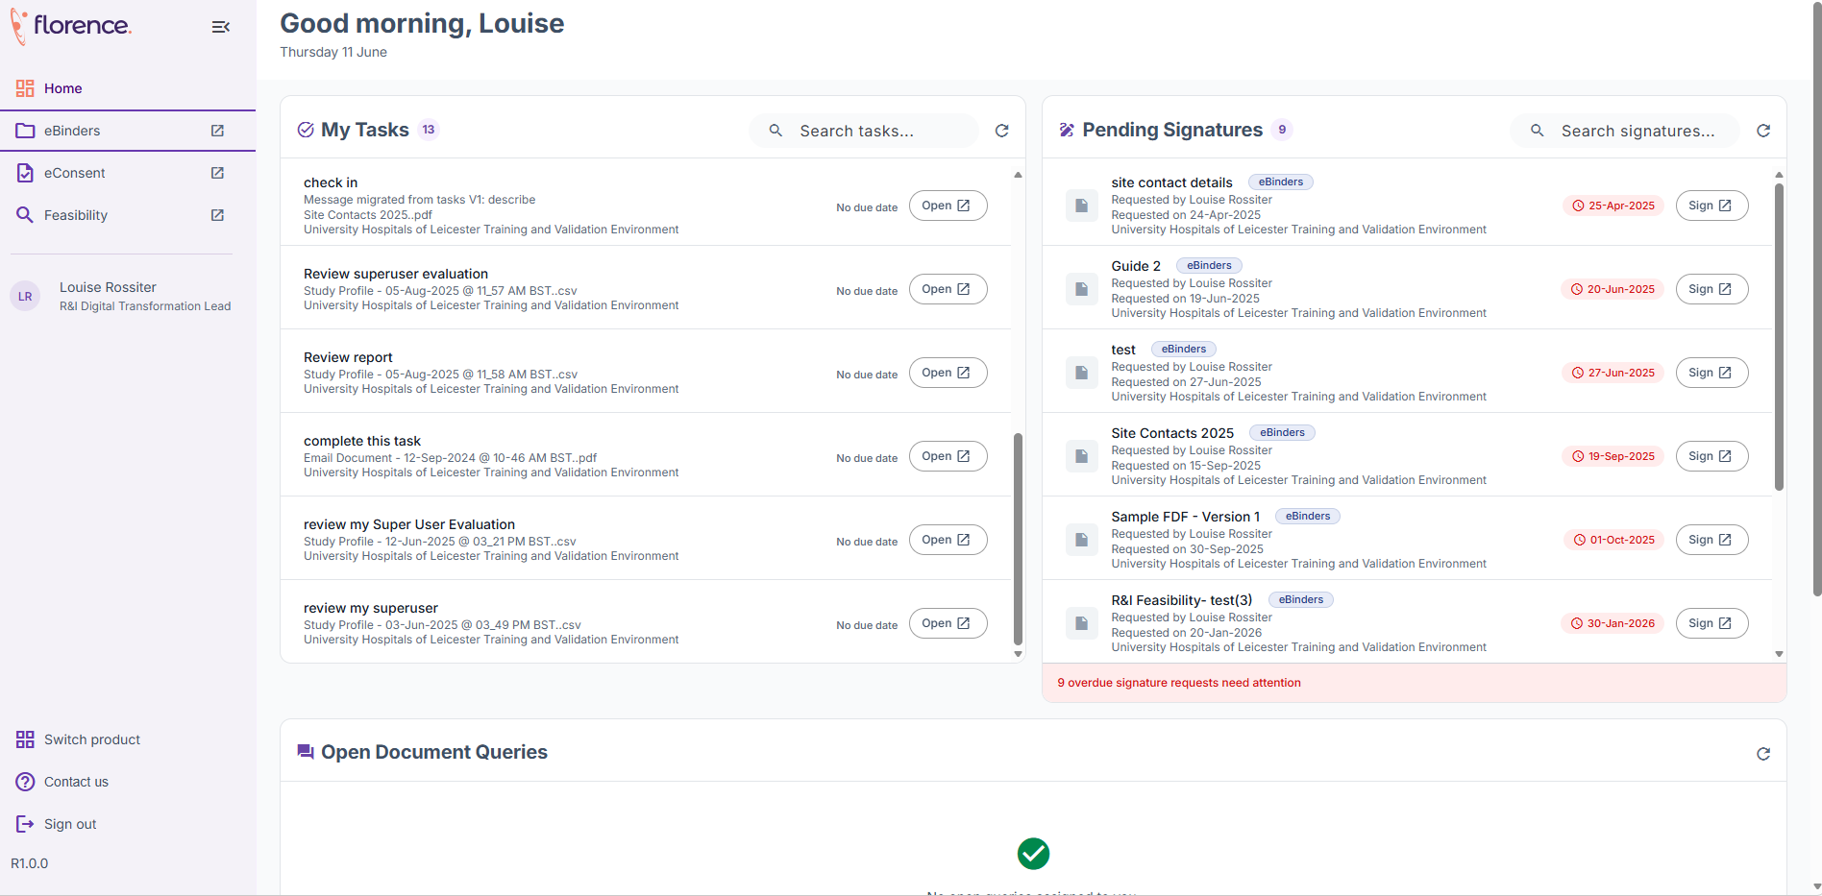

What will I see on the Dashboard?

My Tasks
View all tasks assigned to you across your studies.
✅ See what needs completing first
✅ Tasks are ordered by due date and priority
✅ Click a task to open it directly (it will open in eBinders).

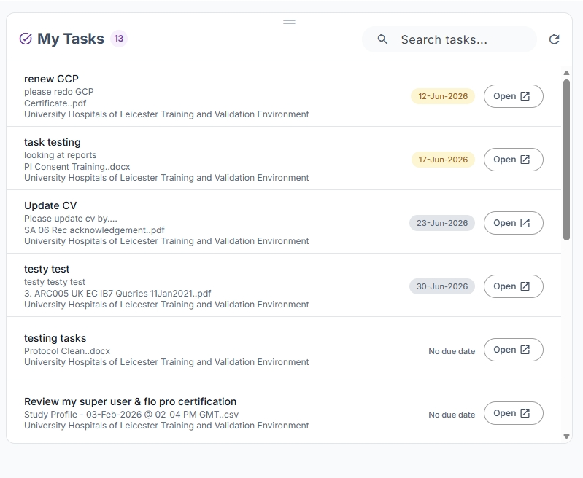

Pending Signatures
View all documents and logs waiting for your signature.
✅ See outstanding signature requests at a glance
✅ Open documents directly from the dashboard
✅ No need to search through study folders

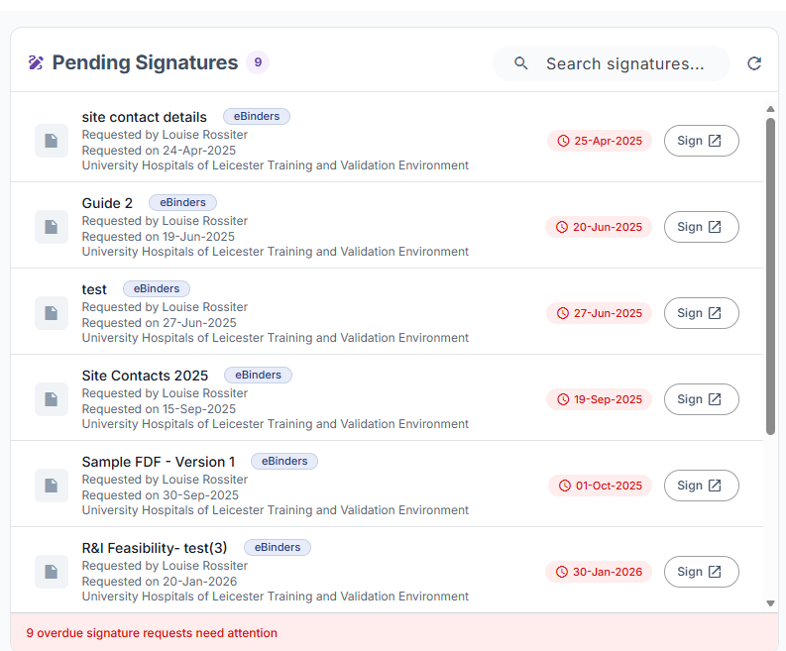

Open Document Queries
View any document queries that require your attention from Monitoring checks.
✅ Quickly identify outstanding issues
✅ Open the query directly
✅ Respond faster to monitor and reviewer feedback
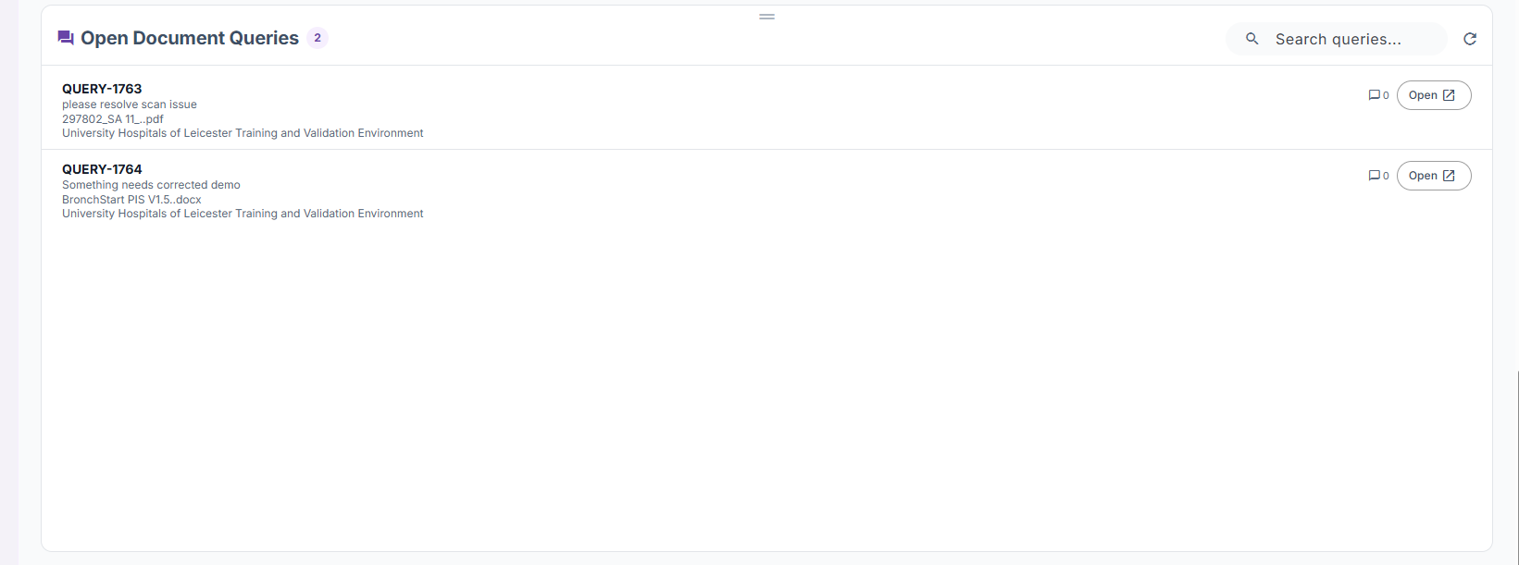

Inbox
(Only visible if you use Team Inbox)
View unread messages from Sponsors/CRO’s that require action.
✅ See new messages immediately
✅ Open the item directly
✅ Complete requested actions more quickly
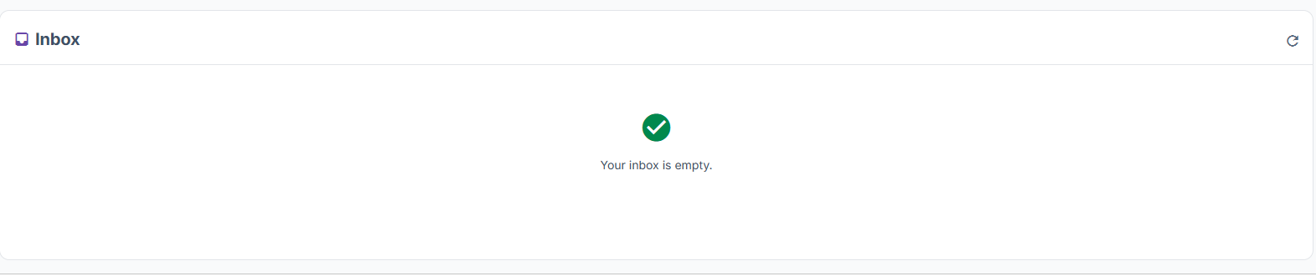

Why is this useful?
Previously you needed to navigate into individual studies to find work requiring attention.
The new dashboard provides a single view of:
- Outstanding tasks
- Signature requests
- Document queries
- Unread messages from Sponsors/CROs (Where this feature is enabled).

This allows you to prioritise work more efficiently and move directly to the item requiring action.

Remember: The dashboard does not replace eBinders. It simply provides a central location to view and access work requiring your attention.
Functionality will be expanded in future releases.

