T 1092 - Accessing Study Binders from the Study Profile

What has changed?
You can now open key study binders directly from the Study Profile without navigating through the folder structure.
This provides quicker access to commonly used study areas and reduces the number of clicks required to find study documents.

Why use this feature?
Using the Study Profile links allows you to:
- Access study binders more quickly
- Reduce navigation through multiple folders
- Move directly from study information to study documentation
- Improve efficiency when working across multiple studies

Accessing a Study Binder via the study profile

Step 1
Access study profiles .
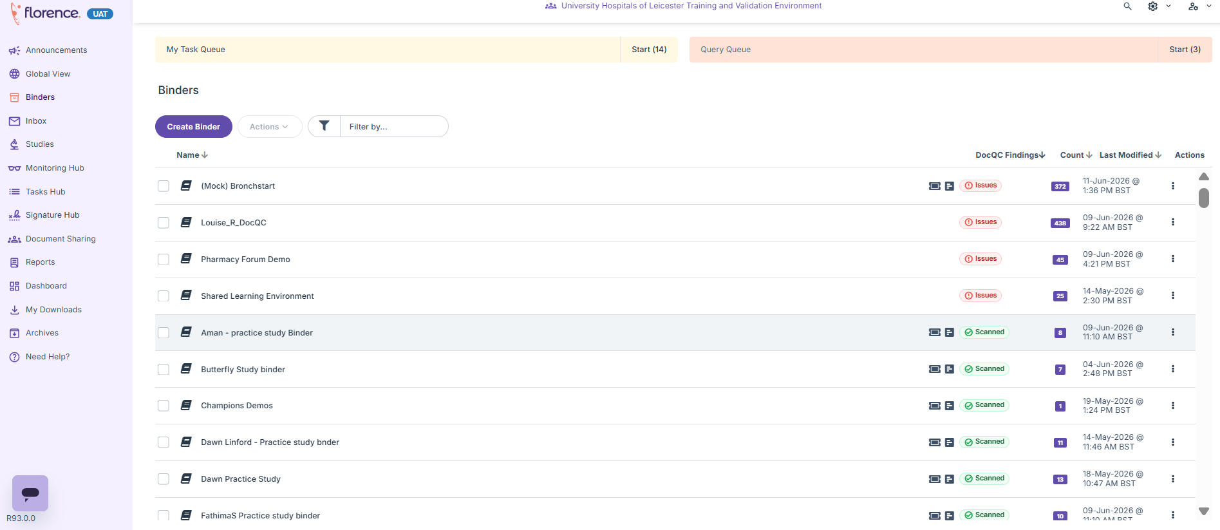

Step 2
Search for the required study using the IRAS number in the Unique Protocol ID Box (as previous).

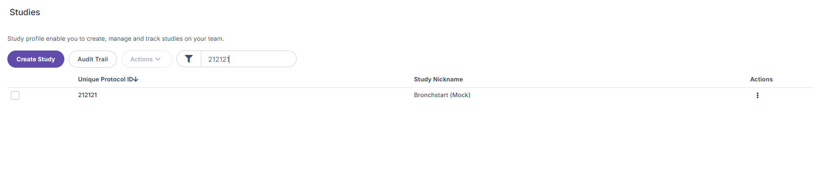
Step 3
Open the required study and navigate to the Connect Study.
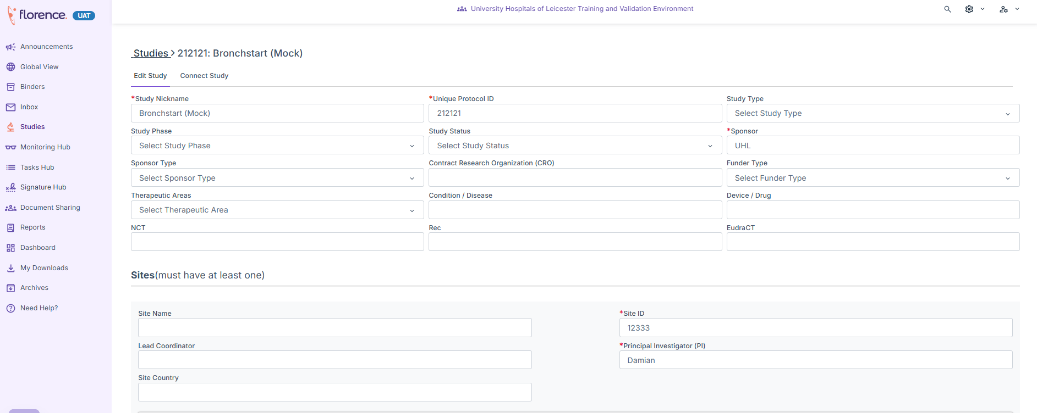

Step 4
Navigate to connected binders and folders.
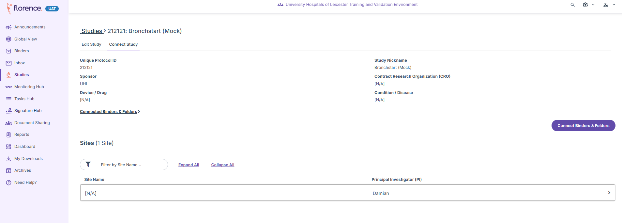

Step 5
Select the required binder link.
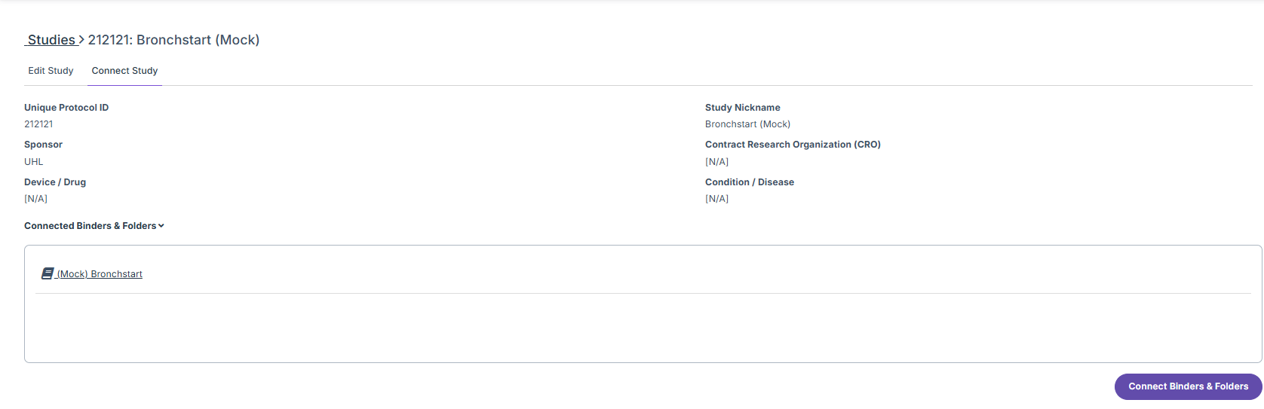

Step 6
Florence will open the corresponding study folder.
Review or manage documents within the folder as required.

Need Help?
If a Folder link is unavailable or not working as expected, contact the R&I Florence team for support – uhl-tr.florence@nhs.net.

Frequently Asked Questions

I cannot see any binder links in the Study Profile. Why?
Binder links will only appear if:
- A Study Profile has been created.
- The Study Profile has been linked to the relevant study binder.

If either of these steps has not been completed, the links will not be displayed.

How do I know if a Study Profile has been created?
Open the study and check whether a Study Profile record exists.
If no Study Profile is present, one will need to be created before binder links can be used.

The Study Profile exists, but I still cannot see binder links.
This usually means the Study Profile has not yet been connected to the study binder.

Can I still access the binder if no links are available?
Yes.
You can continue to access study binders through the normal Florence navigation routes until the Study Profile has been created and linked.

Who is responsible for creating and linking the Study Profile?
For hosted studies, this will normally be completed during study setup.
If you believe a Study Profile or binder link is missing, contact the study setup team or the R&I Florence team for support.

Do these links replace the existing binder structure?
No.
The links provide a quicker route to study binders but do not replace the existing folder structure. You can continue to navigate directly to binders using the standard Florence menus.

