T1093 - Creating and Managing Tasks

Purpose
Tasks can be used within Florence eISF to help manage activities that require action by members of the study team.
At University Hospitals of Leicester, tasks should currently only be used for:
- CV management
- GCP certificate management

Please continue to manage all other study activities using existing processes until further instruction is provided.

Creating a Task

Step 1: Navigate to the relevant document and open it.
Locate the CV or GCP certificate within the central binder.
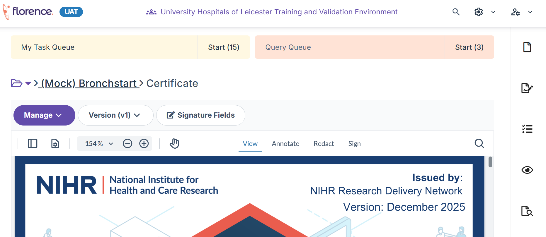

Step 2: Open the Task Hub
Select the task hub from the right hand side.
Tasks can only be created from documents or placeholders.

Step 3: Create a new task
Click Create a new task
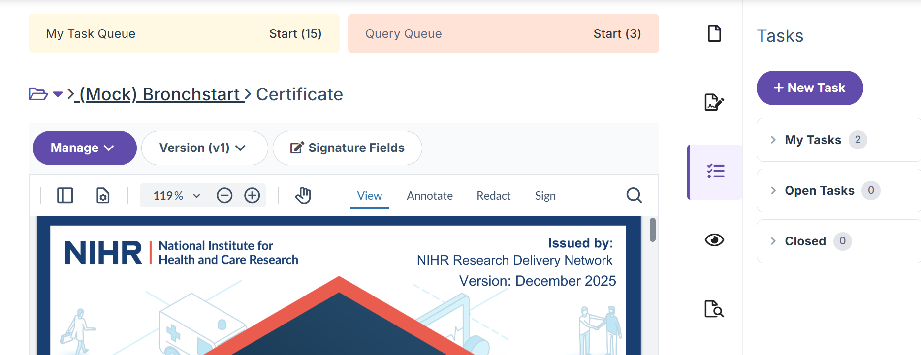
Step 4: Enter the required information
- Task title – Give a clear title for the task – i.e. Update GCP training.

- Description – Give clear instrutions as to the actions required – i.e. update CV or complete GCP refresher.

- Priority Level – Low, Medium or High. This will affect the order in which tasks are displayed on the task dashboard.

- Due date – i.e. date the task needs to be completed by – allow plenty of time for the action to be completed.

- Assignees (i.e. Staff member whose CV/GCP needs updating). Type the staff members name into the search box. If they are not found, contact the shared mailbox: uhl-tr.florence@nhs.net.

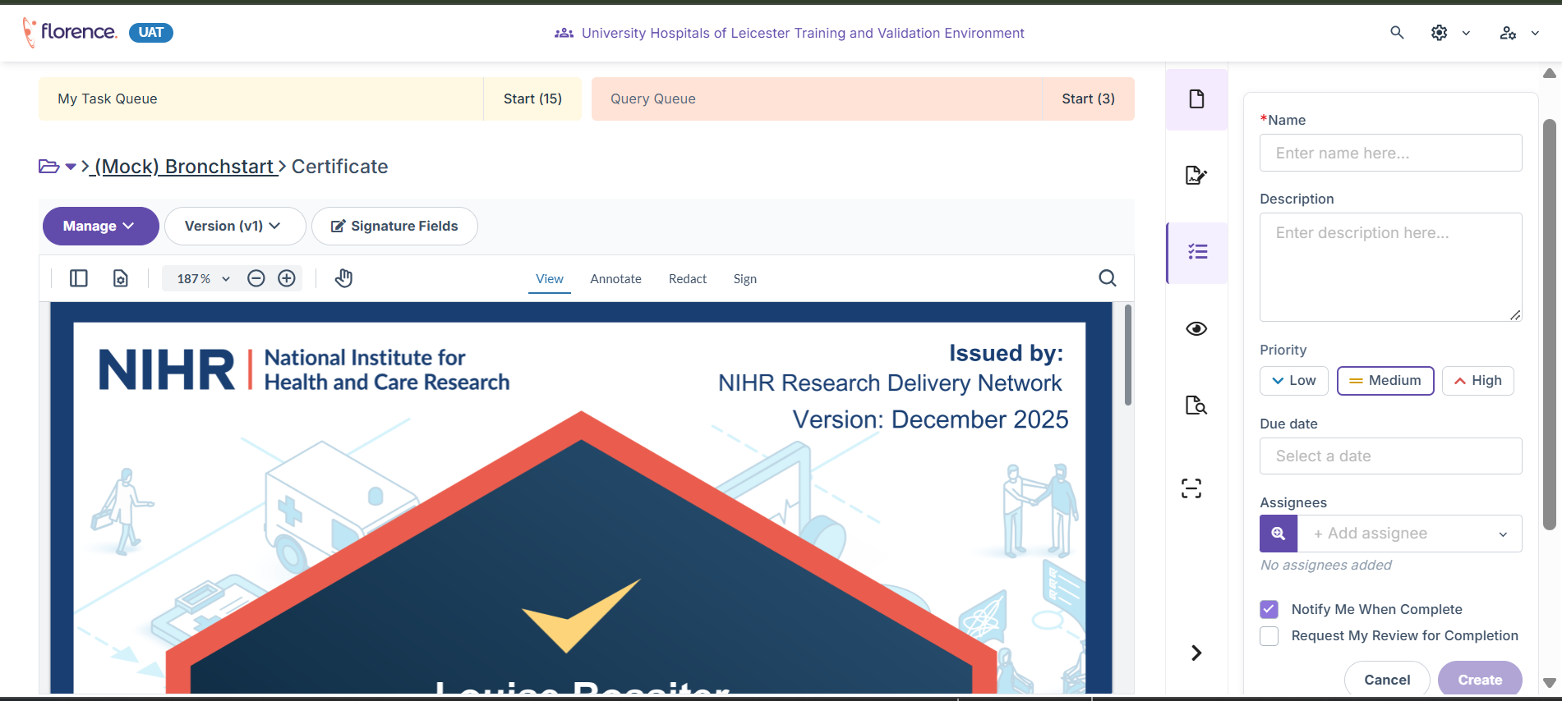
1.
2.
3.
4.
5.

Step 5: Save the task
Select Create to save the task.
The assigned user will be able to view the task within Florence.
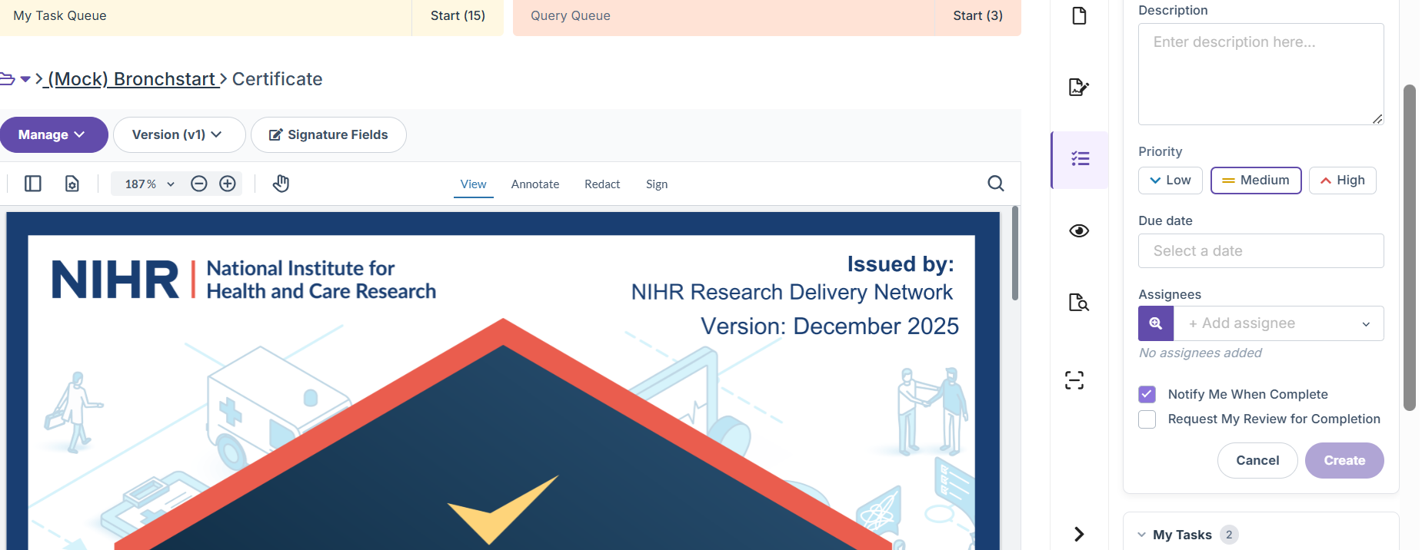

Viewing Tasks
Tasks can be viewed from:

Task Hub
The Task Hub is available in the Florence Dashboard:
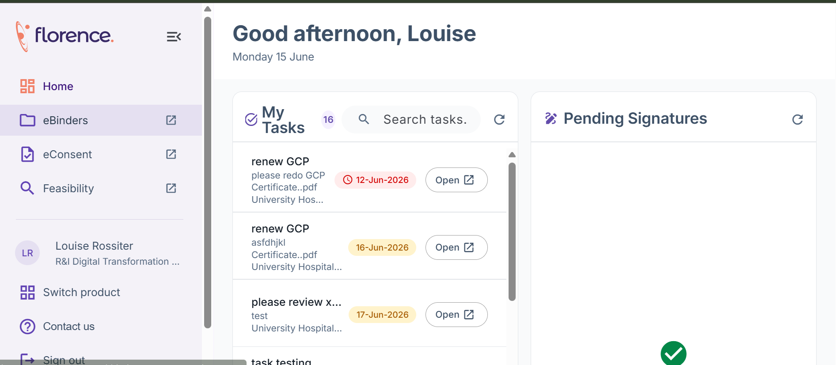
Clicking on Open will take you directly to the task in eBinders:

Study Tasks
Tasks can also be viewed from within the study where they were created.
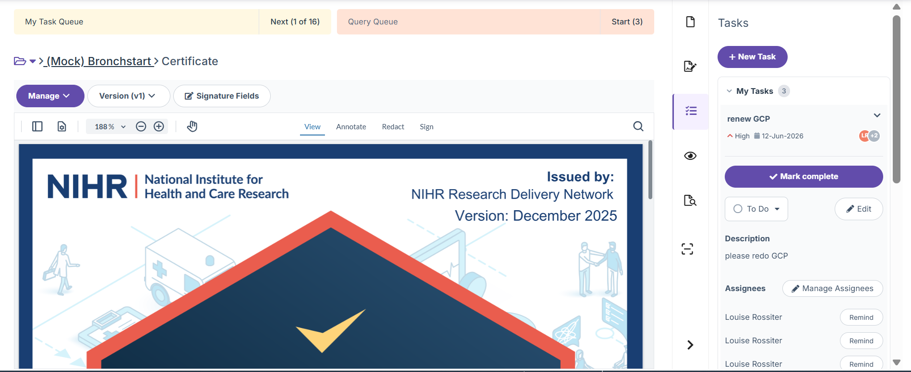

Managing Tasks

Changing a Task Status
Task statuses can be used to indicate the progress of an activity.
Common statuses include:
- Open
- In Progress
- Complete
To change the status:
- Open the task.
- Locate the status field. Click on the dropdown menu to select the most appropriate status (i.e. to do, In progress, On hold).

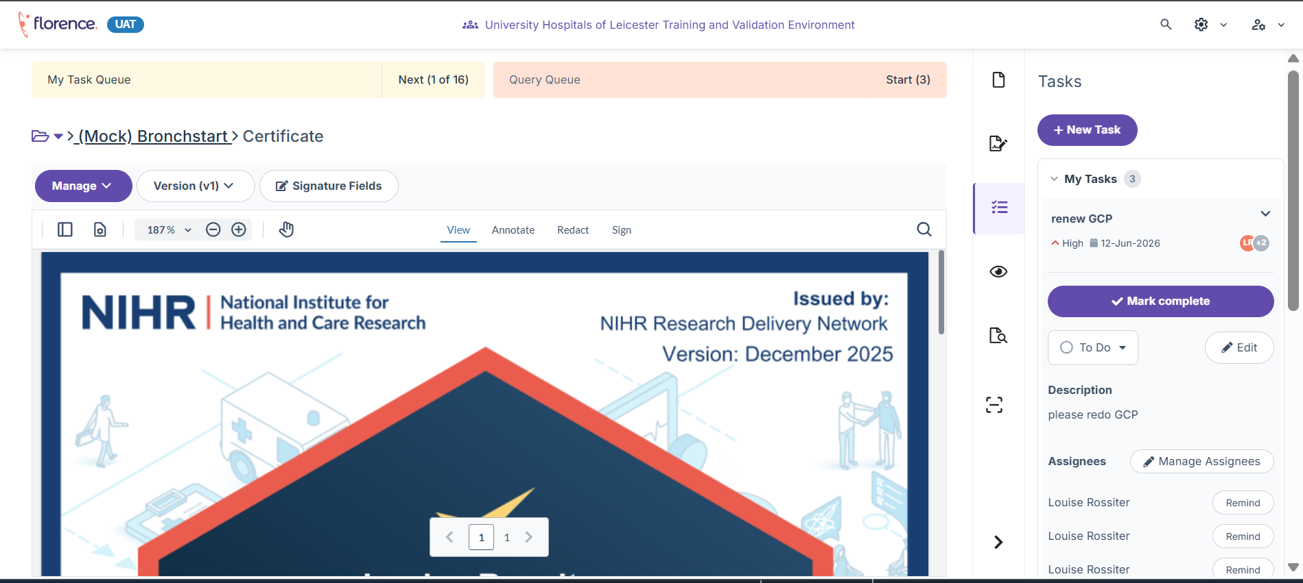
- The status will be automatically saved.

When should statuses be updated?
Status | When to Use
Open | Task has been created, but the work has not yet started
In Progress | Work has started but has not yet been completed
Complete | Required action has been completed
On Hold | Task has been created, but the work is currently on hold (document reason in comments box)
Not Required | Task has been created, but is no longer required (document reason in comments box)
Cancelled | Task has been created, the series of tasks on the document have changed. This is no longer required.

Example: A task requesting an updated CV may be changed to In Progress once the individual has been contacted and Complete once the new CV has been uploaded.

Adding Comments to a Task
Comments can be used to provide updates or record actions taken.
Examples:
- Reminder email sent to researcher on 15 June.
- Awaiting updated GCP certificate
- Updated CV received and uploaded.

To add a comment:
- Open the task and go to the comments section.
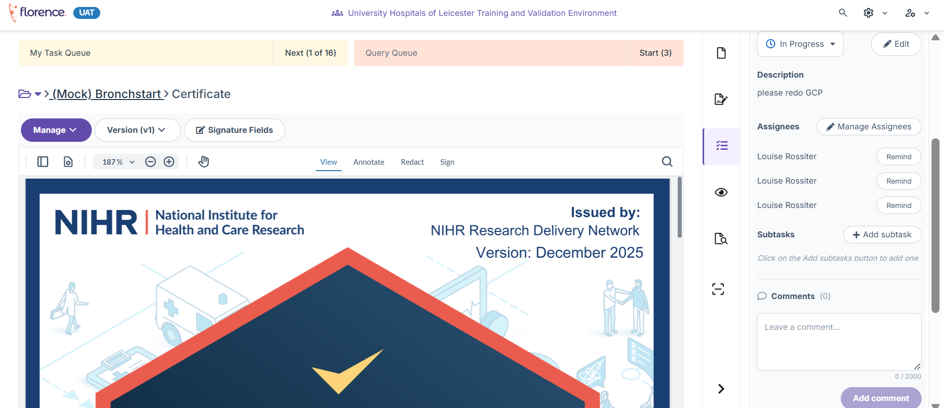
- Type in the comment as applicable
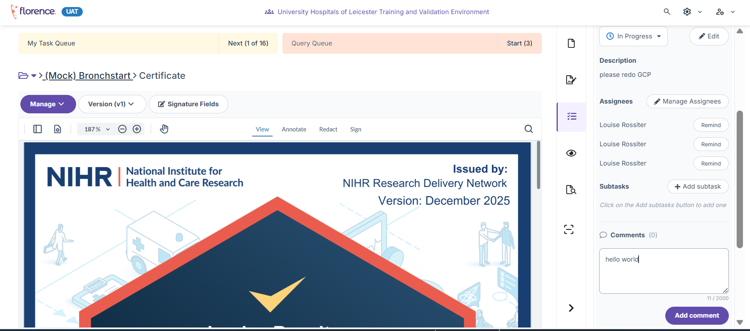

- Press Add Comment when ready to be posted.

Assigning a Task

When creating a task, it should be assigned to the person responsible for completing the action.

To assign a task:
- Open the task.

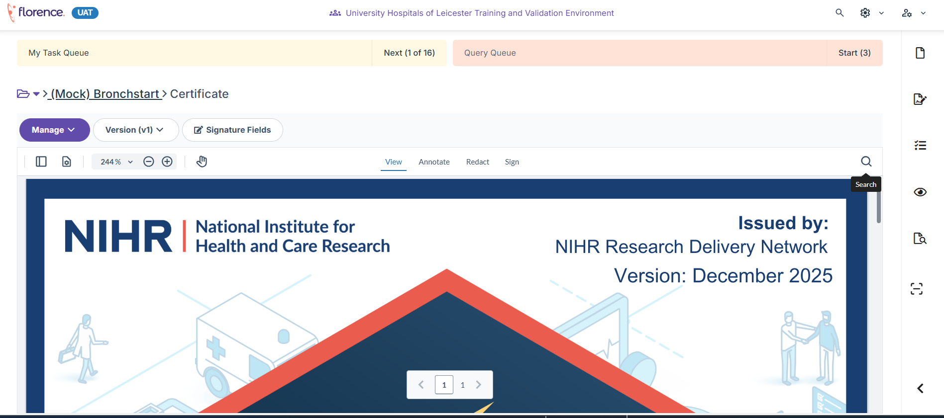
- Locate Assignees
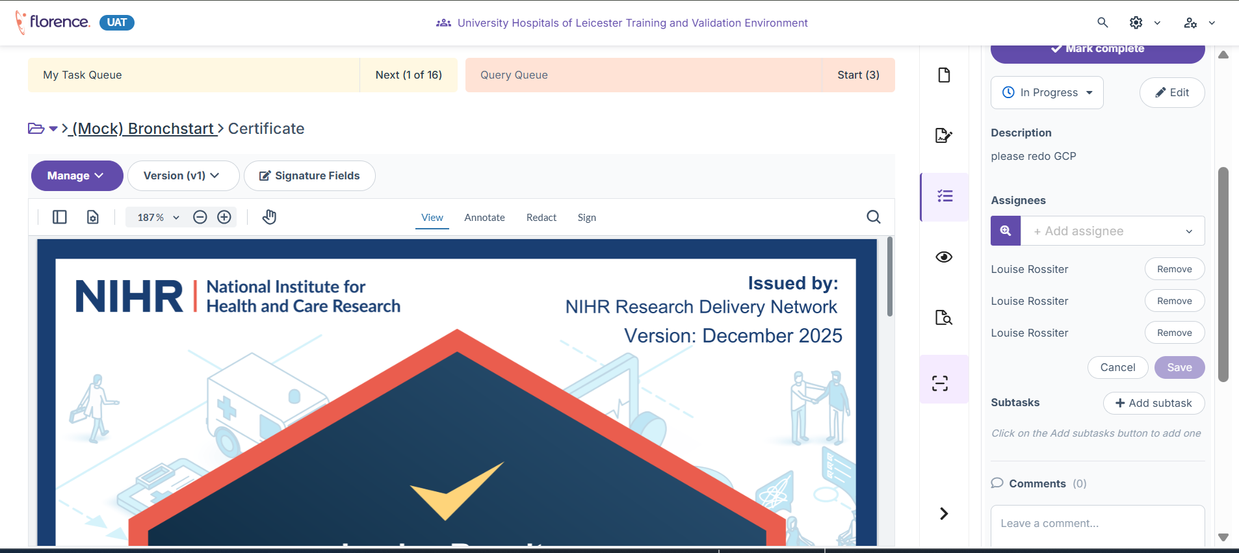
- Type the name(s) of the person(s) the task is to be assigned to. Tick the box beside their name.
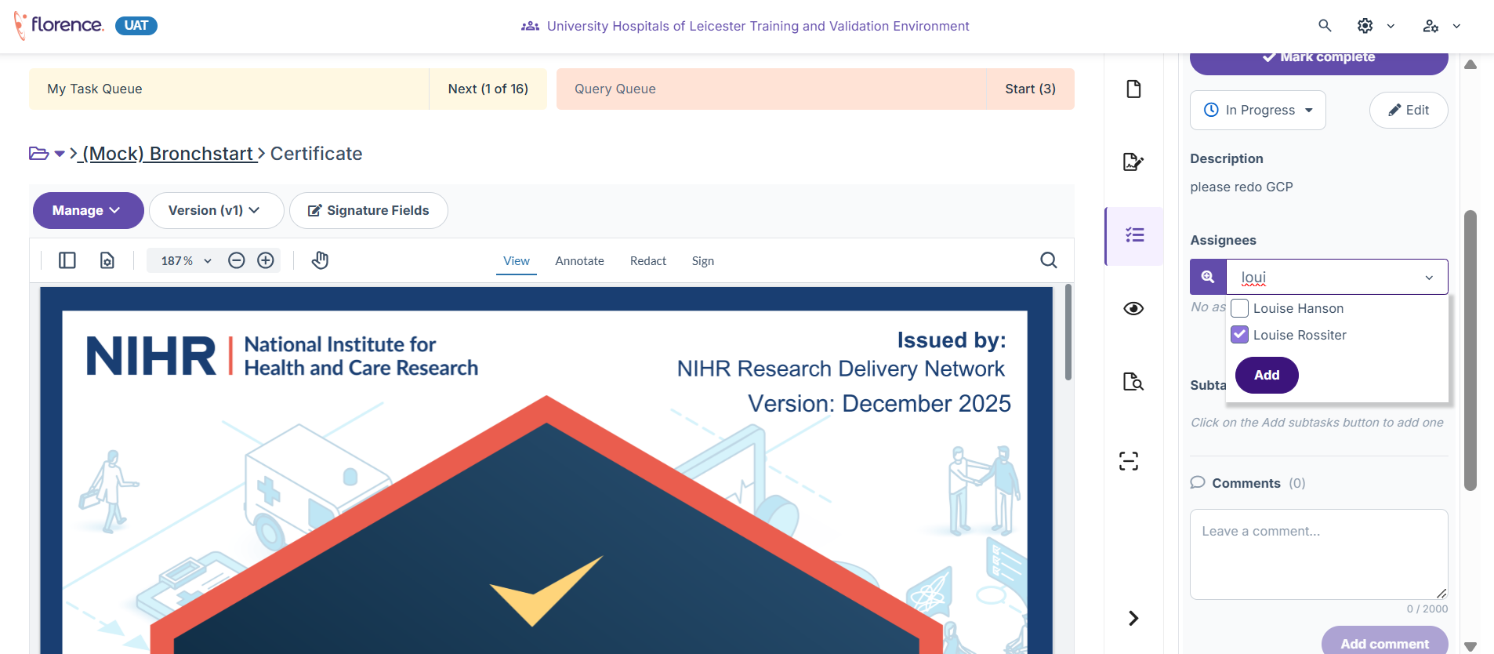
- When all assignees are selected, press add.

Example: A GCP renewal task may be assigned to the researcher whose certificate is due to expire.

Reassigning a Task
Tasks can be reassigned if responsibility changes or the original assignee is unavailable.
To reassign a task:
- Open the task.
- Locate the Assigned To field.
- Remove the users that are no longer required.
- Select the users that are now required.
- Click Add.

Remember - Tasks should only currently be used for the following:
✅ CV renewals
✅ CV review reminders
✅ GCP expiry reminders
✅ GCP certificate updates

Do Not Use Tasks For
❌ Study setup activities
❌ General project management
❌ Monitoring actions
❌ Site file reviews
❌ Meeting reminders
❌ Local workflow management

These activities should continue to follow existing UHL processes until further guidance is issued.

Need Help?
If you experience difficulties creating or managing tasks, please contact the Florence Mailbox – uhl-tr.florence@nhs.net
When reporting an issue, include:
- Study title
- IRAS number
- Screenshot of the issue (where possible)
- Brief description of what happened

